

Duo application

Design document



Justice Dreischor

Kalina Atanasova

Class E-S34

Contents

Target group 2

Persona 3

Participants 3

First cycle 5

First Sketches 5

Wireframes Main screen 7

Login Page 7

Event dialog page Review page 8

Host event page Host profile page 10

Add/edit event 10

Digital Prototype 1 11

User testing 12

Issues 12

Second cycle 13

Sketches 13

Wireframes 14

Main screen Find party screen 14

Group screen Find buddy screen 15

Request screen Create party 16

User testing 17

Mayor issues 17

Issues 19

Project Description

We decided to create an application that brings people together who like going to parties/concert but doesn’t have any buddy to go with. Our application will be able to find a random buddy for you based on the party you have selected or a specific buddy you have chosen. It can also be used for people who are interested in joining the local parties and see real time location of their buddies.

# Target group

Party goers, people who want to explore new places in the city, people who want to join an event but prefer to find a partner who they can go with first.

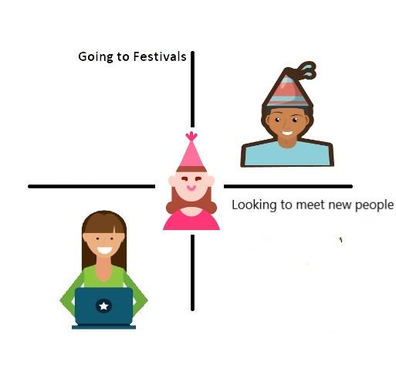

# Persona

|  |  |
| --- | --- |
| Gender: Male  Name: John  Age: 21  Working position: College student  Background:  John is an expat in the country and wants to explore events – parties in particular, that he is interested in. He doesn’t feel comfortable going to parties where he doesn’t know anyone. He always goes to parties with groups of friends but he doesn’t know any people in his new social environment that share the same interests as him. He wants to find more people that he can hang out with and create connections based on his passions.  Motives:   * New in the town and wants to explore new places and meet new people * Doesn’t know many people with the same interests as him and want to find friends based by the type of events that he is interested in   Goals:  - Create new connections with people  Applications that he uses:  Facebook, Instagram, Spotify, Meetup |  |

# Participants

|  |  |
| --- | --- |
| Valentine, 20  Roles: Software student  Video link: <https://youtu.be/nN7r9KrbWH4> | Victor, 19  Roles: Technology student  Video link: <https://youtu.be/nW61rdkllXw> |
|  |  |

Here above you can see the people who has participate during our user testing.

Brainstorming Sessions

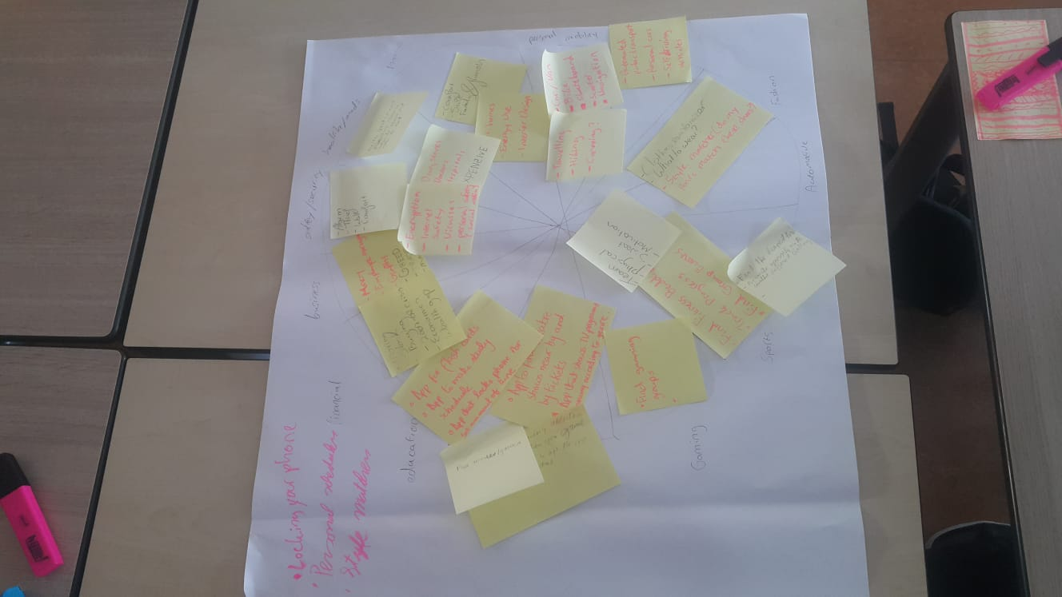

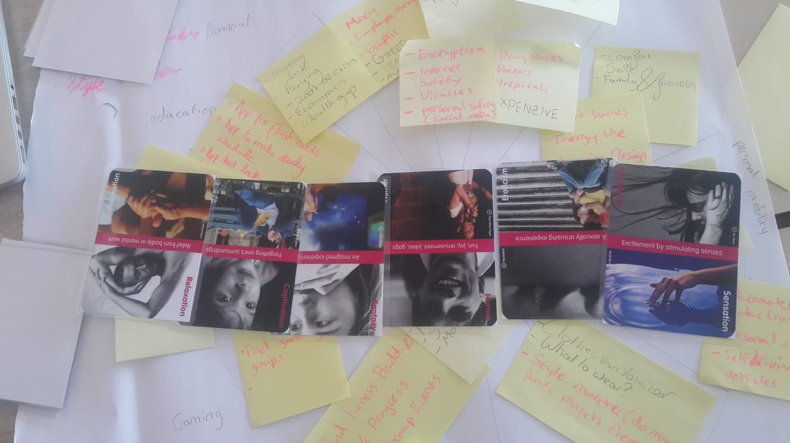

# First cycle

## First Sketches

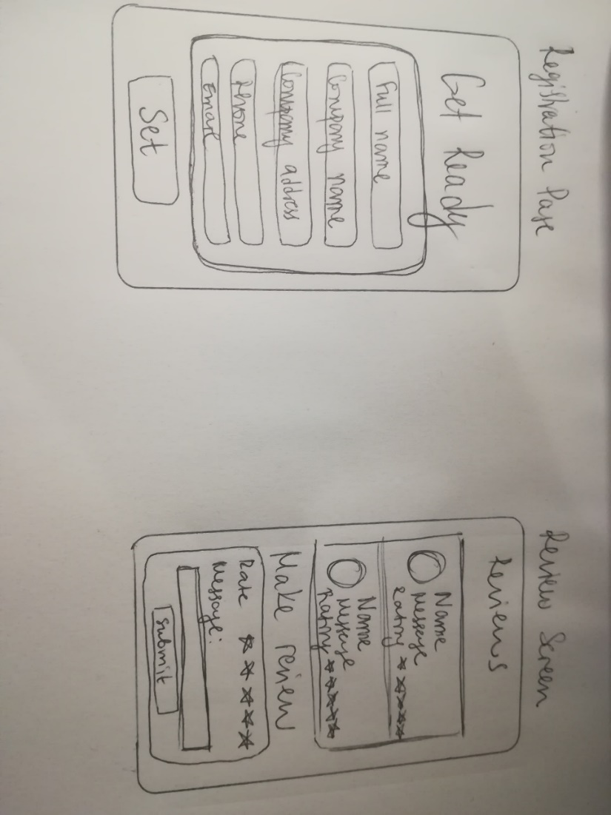

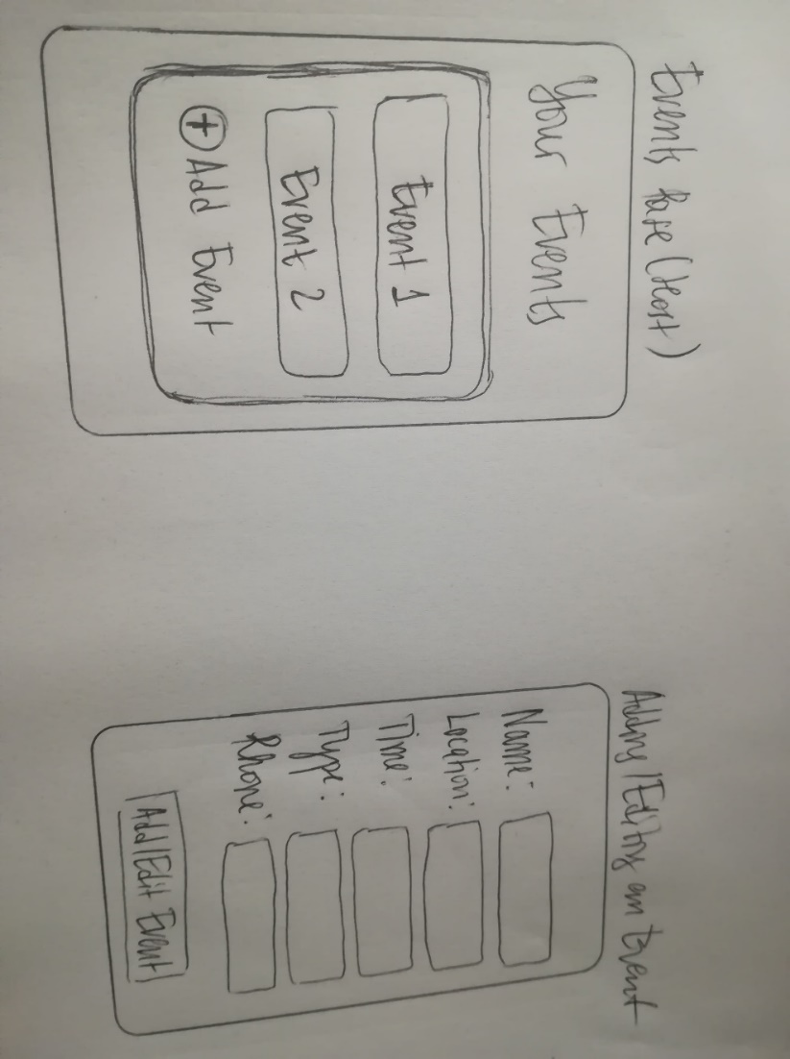

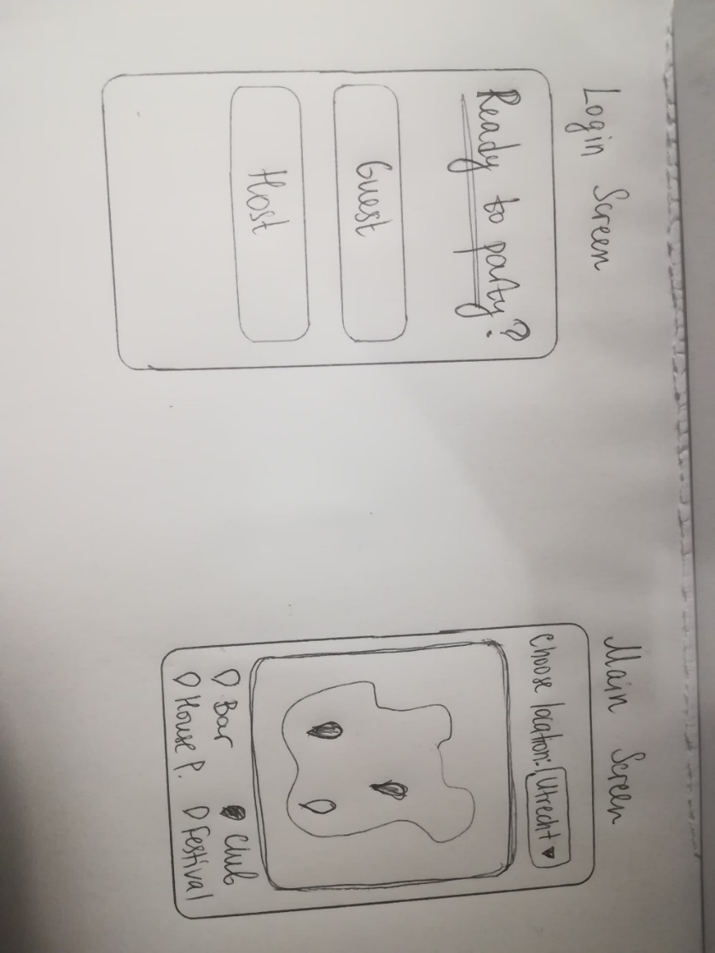

### Wireframes Main screen

### Login Page

As you can see in the screenshot above there is a login page and a map with different dots, each dot represents a type of party where the user can filter them by clicking on the dots under the map. If a user clicks a dot on the map, a dialog will open with information about the event and the user can choose to get reviews or direction of the party.

### Event dialog page Review page

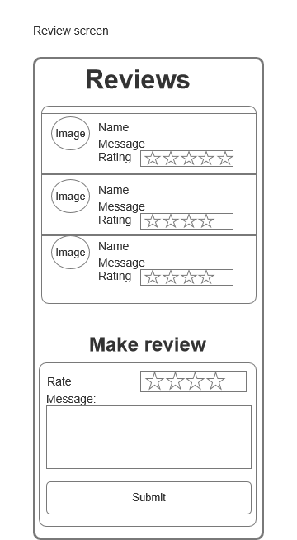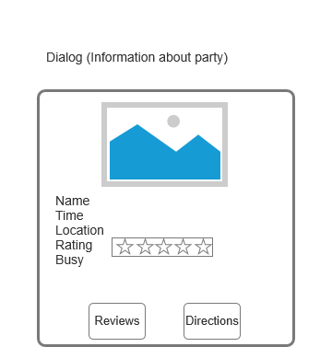

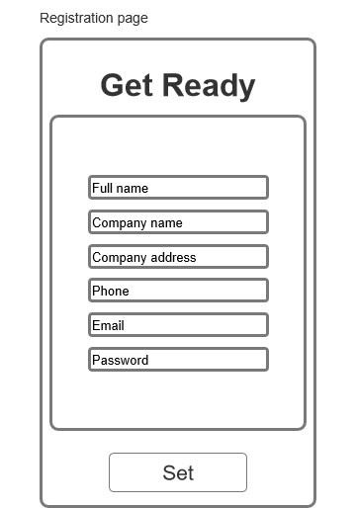Host Login page Host registration page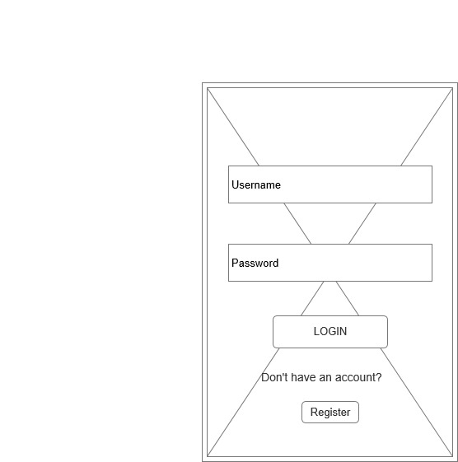

As explain above, when the user clicks a dot on the map a dialog will open with information about the event and the option to see the reviews and directions.

For the review page the user can see all the ratings of each user or they can create their own review.

In the screenshot above you can see the login and registration page for the person who is going to create the party.

### Host event page Host profile page

### Add/edit event

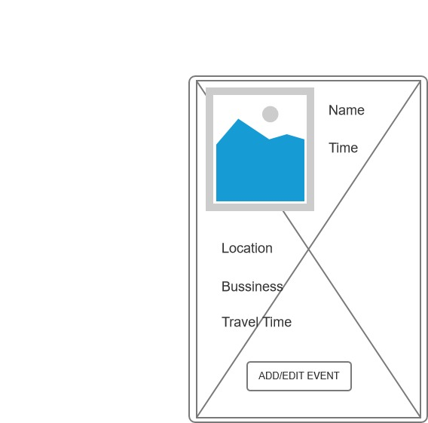

On the left screen above you can see the main page of the host and all the event that the host has created. On the right screen shot you can see the profile page of the host and underneath you can see the edit/add page for a specific event.

## Digital Prototype 1

In the video below you can see a protype of our idea.



## User testing

The issues that we found were based on the feedback that we got from different people/teachers.

### Issues

* Two separates main screen/login/registration
* Main screen looks boring and look the same as google maps
* How does the person know how safe a party is?
* Missing the selling point

# Second cycle

## Sketches

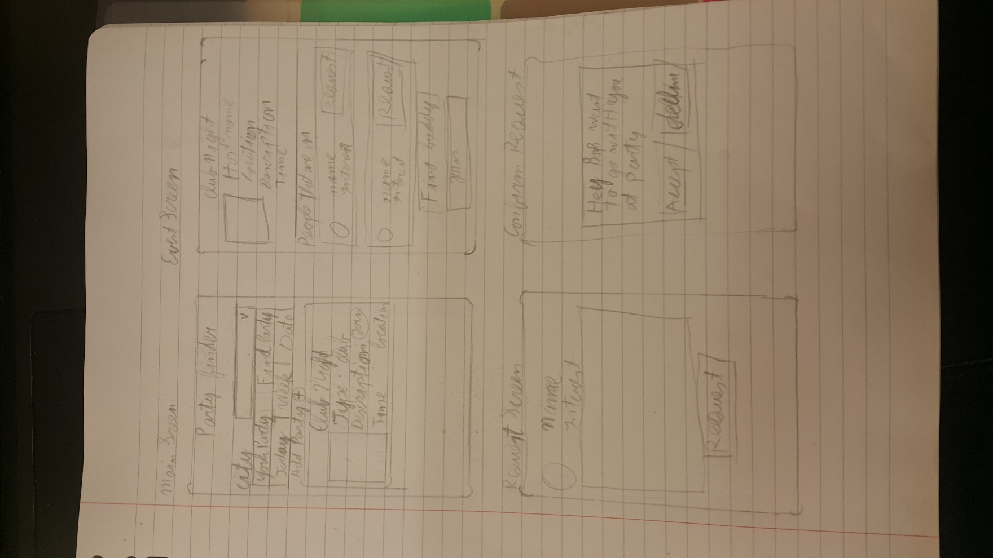

## Wireframes

### Main screen Find party screen

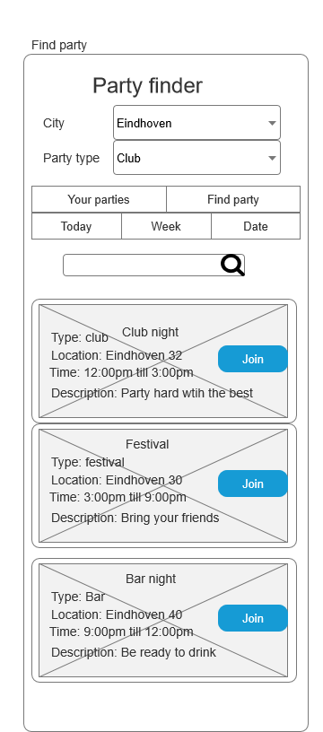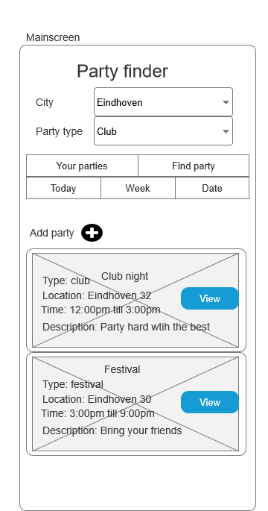

In the picture above you can see two screens, on the left you can see the user parties that that he/she has created and on the right is to find parties to join. To find a party the user must first select the city, type and date.

### Group screen Find buddy screen

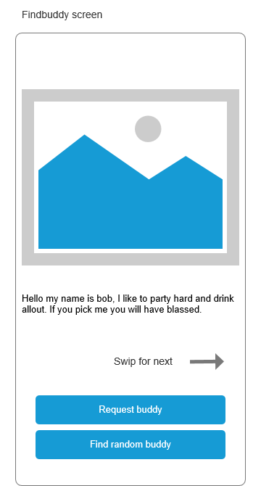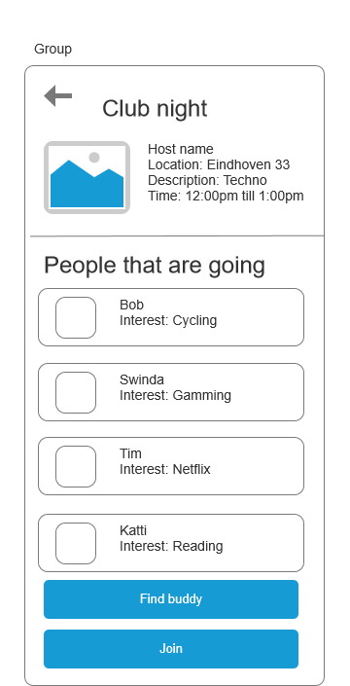

In the picture above you can see two screens, on the left you can see the party information and all the people that are going to that party. The user will be able to join a party by clicking on the “join” button, automatically the user will be added to that party if there is any space left. After that the user will be able to find a buddy to go with by click on the “Find buddy” button.

### Request screen Create party

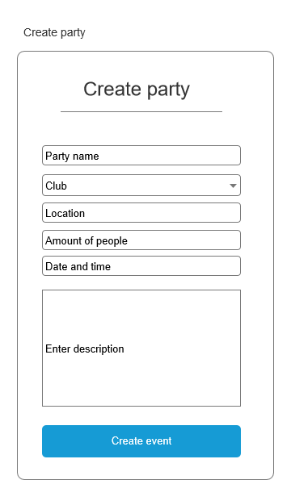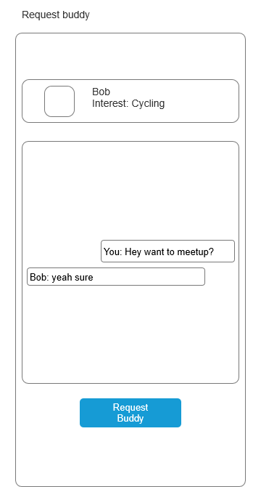

After the user has found a buddy the left screen will pop where the user can send a message to his/her buddy. But the user can only send one message at first until the buddy has accepted the request, after the request has been accepted, they will be able to communicate freely. If a user wants to create a party, they will need to press the add button from the main screen and the right screen shot will pop up where the user will need to fill the party information and then they can press the “create event” button.

## User testing

### Mayor issues

* User didn’t know what was the difference between request buddy and find buddy
* User was afraid to press the join button

|  |  |
| --- | --- |
| User didn’t know what was the difference between request buddy and find buddy  Problem can be found at 3:09 to 3:52  <https://youtu.be/nN7r9KrbWH4> | Suggestion   * Instead of making two buttons, make just one button” find buddy” * Make a “find buddy” screen where people can see pictures and description of each person just by swiping   The problem here was there no indication explaining what is the difference between request buddy and find buddy |

|  |  |
| --- | --- |
| User was afraid to press the join button  Problem can be found at 8:50 to 9:11  <https://youtu.be/nN7r9KrbWH4> | Suggestions   * Instead of “join” change button to “details”   As you can see in the screenshot the main page shows the parties with a “Join” button, but when you click it doesn’t join directly, you will see first the details and then you can join. |

### Issues

* The user didn’t like that the main screen starts with “your parties”
* User was afraid to press the join button
* User was confused how to create a new party
* User didn’t know what was the difference between request buddy and find buddy
* User wanted to see more information about each buddy
* User wanted to choose to be available or not for buddy request.